Dear Ingham County 4-H Member:

The Ingham County 4-H Council invites you to apply to become a National 4-H Congress Delegate for the 2020 program. National 4-H Congress is a five-day event that engages high school aged 4-H members in leadership, citizenship, global awareness, and inclusion. Participants not only have the opportunity to participate in state-of-the-art educational workshops and hear from world-renowned speakers, they also have the opportunity to network with other 4-H members from across the United States. The event is held in Atlanta, Georgia during Thanksgiving break 2020.If you are interested, complete the following requirements to be eligible for this event:

1. Submit the application below to Glenda Weiss ([weissgle@msu.edu](mailto:weissgle@msu.edu)) by October 11, 2019. Your application must also include two letters of recommendation. At least one from a 4-H volunteer or extension staff member and another one from a community member, however both can be from 4-H volunteers. Parents and family members are not allowed to sign the recommendation letters.
2. Interviews will be held the week of October 14th-17th and will be arranged by Glenda Weiss.
3. After the completion of the trip, youth are required to provide a presentation regarding what they learned to the Ingham County 4-H Council, at the following Ingham County Awards Banquet, and to all entities that provide scholarships for the trip. Thank you letters are also required for all entities that provide scholarships to the trip.
4. The cost is the trip is approximately $1,450 and the youth are responsible to this fee, however we encourage youth to fund raise for the event.
5. Youth ages 14-19 can attend. See the website for more information: <http://national4-hcongress.com/>

Good luck!

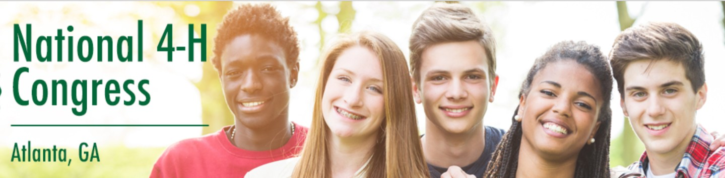The Ingham County 4-H Council

***It is highly recommended that all youth applicants join the Ingham County 4-H Teen Ambassadors Program in 2019-20. If accepted as a National Congress delegate, many scholarship opportunities are available to Ambassadors. For information on how to become an Ambassador and for payment due dates,*** [***please contact the 4-H Council***](http://4h.missouri.edu/events/cwf) ***through the MSU Extension office.***

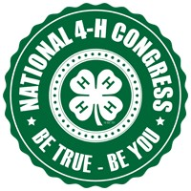

Please print in ink or type.

#### Ingham County 4-H

**National 4-H Congress 2020**

**Delegate Application**

Last Name

First Name ­­­­­­­­

Middle Initial

Male

Female

Birthdate - -

Address

City Zip

County Grade in School, as of Jan 2020 ­

Your Home Phone ( ) Your Cell Phone ( )

Your Email address

Parent/Guardian’s Name

Parent address (if different than yours)

Parent Home Phone ( ) Parent Cell Phone ( ) Parent Email

Why do you want to attend the National 4-H Congress? Response must be a minimum of 250 words and a maximum of 500 words.

What do you hope to gain from this experience and how do you plan to share information when you return? Response must be a minimum of 250 words and a maximum of 500 words.

List what you consider your two (2) most valuable leadership experiences as a 4-H member: Response must be a minimum of 250 words and a maximum of 500 words.

Have you participated in any civics/government classes, activities or organizations? if so, briefly list here:

As parent/guardian of , I understand that s/he is applying to attend the 2020 National 4-H Congress in Atlanta, GA. I have read the information stated in the flyer and have thoroughly reviewed the Congress website: <http://national4-hcongress.com/> and I also understand that it is highly recommended that my child join the Ingham County 4-H Teen Ambassadors in 2019-20 whether or not s/he is chosen to be a delegate to Congress. Many leadership and scholarship opportunities are available to Ambassadors throughout the year.

Parent/Guardian Signature

Date

4-H Youth Signature

Date

Return this application to **Ingham County Extension Office by** October 11, 2019. Delegates will be announced at the County Awards Banquet in November